JANUARY-FEBRUARY 2023 VOLUME 6 ISSUE 1-2

NORTH AMERICAN
NATURAL SCIENCE
SECTION CONFERENCE
The Evolving Course of Science
Science and the Foundation Stone
at 100 years
May 11-14
Rudolf Steiner House
Ann Arbor, MI
See page 3.

Contents
Editor’s Note 2

Section News

Save-the-Date: Section Conference May 11-14 3

Local group initiative 4

NATURA newsletter from the UK 5
Research

Michael Shope: Beech buds dancing with the Moon 7

Events
Calendar of Events 10
Please support our work 11

Steering Committee
Of the Natural Science/
Mathematics-Astronomy Section
Judith Erb
Jennifer Greene (Representative to Collegium)
Barry Lia (Editor; Treasurer)
Andrew Linnell (Webmaster)
Maria Morales
Mark Riegner
Gopi Krishna Vijaya

Editor’s Note
We have our first research report! Michael Shope tells us of his ongoing beech bud research. He planted a sapling at his home in Seattle, WA, in order to make daily measurements (see page 7).
In Section news, we make a Save-the-Date announcement for our upcoming North American Section Conference in May, 11-14. (see page 3). Bios and more in next month’s issue.
We also announce the formation of a local study group initiative, taking up Steiner’s lectures to academic audiences in Anthroposophy and the Natural Sciences (GA 75). We hope to inspire other members to promote our Section’s mission in this way in their own locales (page 4).
Lastly, we publicize the resumed newsletter of the Natural Science and Mathematics Group in Great Britain (page 5). This current issue of NATURA reports on meetings in the UK and in Dornach. Also included is an obituary of Wolfgand Schad.
You will find another cartoon from our Facebook page (page 10). And don’t miss the link to a hilarious video on living with an Internet of Things! Visit our FB page for thought-provoking links on science and technology as well.
And we are always grateful for your generous financial support (page 11). We expended considerable funds for three American members to present at the Section’s Autumn Conference at the Goetheanum last October.
For ease of on-screen navigation, we have set up the Contents subheadings as internal hyperlinks (without underline) and put “Back to top” links at the bottom of each page.
As always, the Correspondence welcomes pilot research reports, comments on current scientific research and news, book and article reviews, letters from readers, reports on meetings and workshops, and announcements. There will be editorial review. For submissions, click here. We look forward to hearing from you. Please send feedback here.
Barry Lia, Ph.D.
Correspondence Editor
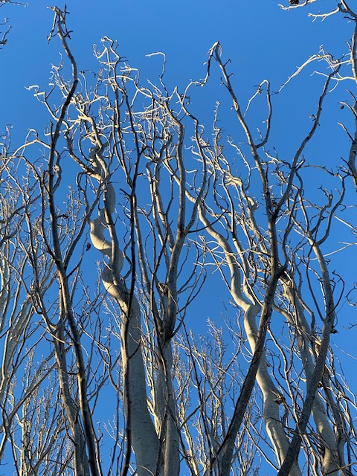

Section News
Save-the-Date
North American
Natural Science Section Conference
May 11 through 14
Rudolf Steiner House, Ann Arbor, MI
Registration here.
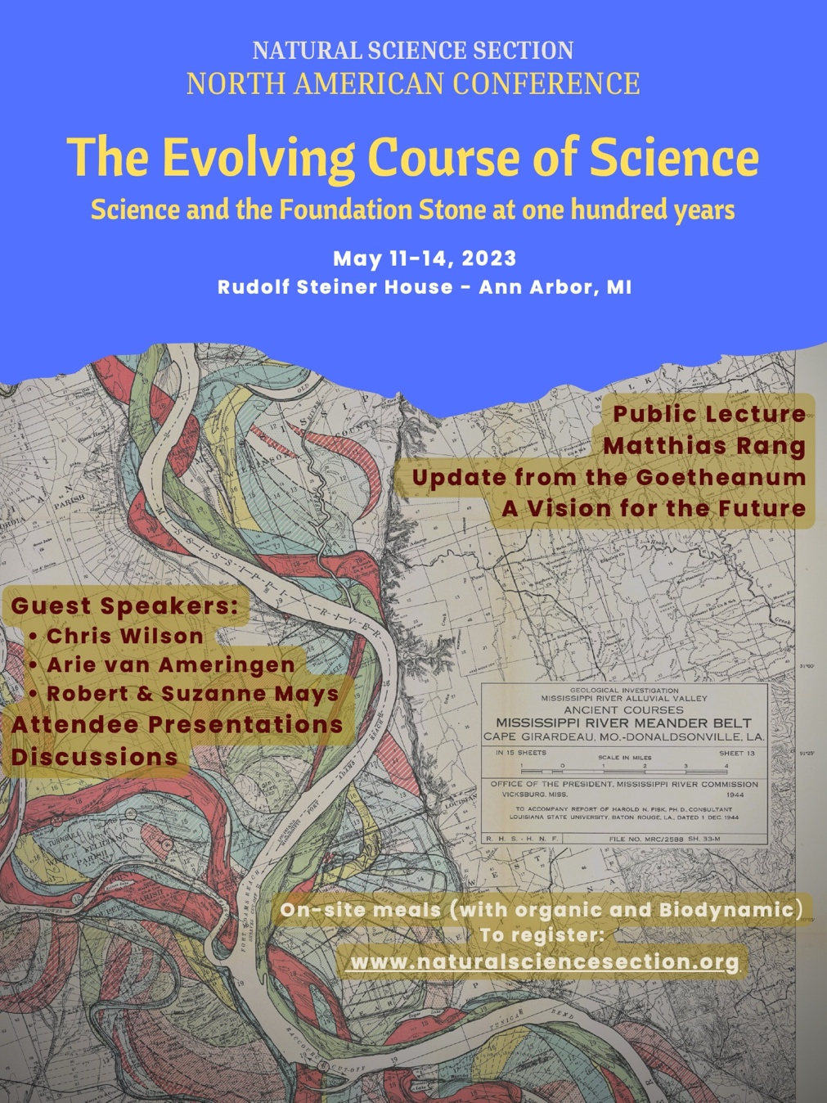

Local Group Initiative

Nearing the 100-year anniversary of the founding of the School for Spiritual Science as an esoteric core for the anthroposophical movement and the Anthroposophical Society, a call has gone out to reinvigorate Steiner’s intention for anthroposophy. Given that our world is now dominated by science and technology, it might behoove us first to enrich our own understanding of our technological age from an anthroposophical point of view. With this aim, the Seattle Branch and the Natural Science Section of the School for Spiritual Science of the Anthroposophical Society in America has set up a local study group beginning with an ideal set of lectures for this purpose.

We encourage other Section members to take up such initiative in their own locales.
Perhaps we’ll build interest for regional conferences in the future.
You might work with the sample announcement below:

TAKE INTEREST IN SCIENCE
…from an anthroposophical point of view!

You need not be a scientist to be interested in what Rudolf Steiner had to say about science. It may surprise you! And it should be of interest to us all, living as we are in this technological age.

Everyone is welcome to join us in person or online to study Anthroposophy and the Natural Sciences: Foundations and Methods (GA75), a collection of public lectures Steiner gave to academic audiences, aiming “to characterize what anthroposophically oriented spiritual science really wants to be. …Indeed, anthroposophically oriented spiritual science is convinced that any serious and sincere striving in the modern sciences, if pursued consistently, will necessarily ultimately lead to its method. I want to speak to you in a scientific sense because, after all, I myself did not start from some view of theology, from some questions about worldviews, or from philosophy in the sense in which people usually understand those things. Rather, I started with technical studies. And these technical studies led me to the realization that this spiritual science is a necessity at this time in our historical development.” (p.1)
See a description of the book here.
NATURA newsletter from the UK
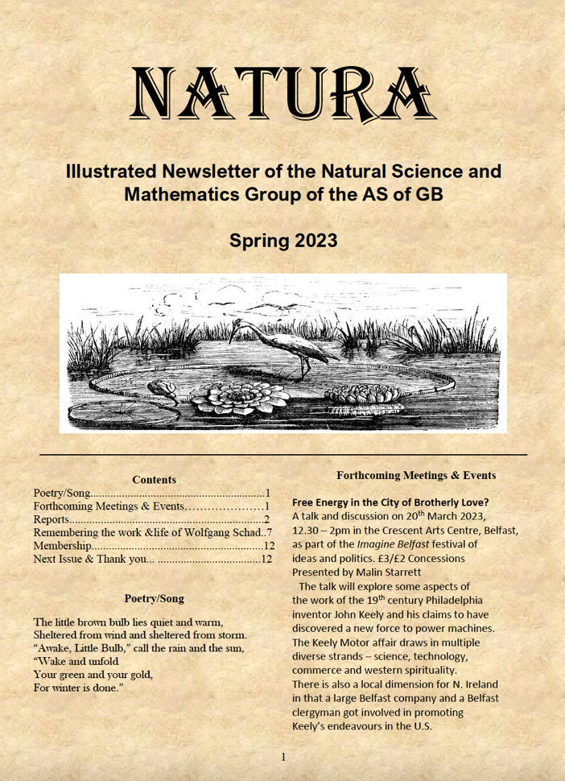
The Natural Science and Mathematics Group of the Anthroposophical Society of Great Britain has also resumed sending out their email newsletter.
NATURA will be published Spring and Autumn. Membership in the group is £10 (UK), £12 (Europe) or £14 (elsewhere). Please contact Simon Charter, simon.charter@live.co.uk
Unless you happen to be in the UK at the time, announcements of events and meetings will be of less interest for us than subsequent reports on events in Great Britain and the Continent.
In the current issue, there is a report by Malin Starret on the Autumn Conference of the Natural Science Section in Dornach last October. Moderation in the utilization of technology at a conference on technology is praised. There is a humorous anecdote about the young person in charge of the video camera being occupied by his smart phone, as well as concern about situations where speakers might be intimidated or guarded about presentations broadcast to any and sundry on the internet. The author offers rather conservative, or shall we say cautious, critiques of some presenters’ stances on technology. He closes with words about his own project presentation, which attempted to bring understanding to a controversy that arose in 1922 when a fellow who worked in the physics department of a London university “challenged the results stated by Steiner regarding the coloured shadows experiment described in the Seventh Lecture of the Light-Course.”
Alex Murrell reports on the Science Group’s annual meeting last year. It is hoped that the presentations will lead to articles in NATURA or on their website. Many of the presentations dealt with geology and earth evolution. Spurred by re-reading lectures Steiner was delivering 100 years ago, Alex adds some thoughts of his own on an important passage in The Origins of Natural Science: “…a healthy discussion concerning the relationship between anthroposophy and science must come to pass within our movement. Anything that goes wrong in this respect can only do grave harm to anthroposophy and should be avoided.”
A report follows on a recent Colour Workshop at Ruskin Mill Field Center, featuring Matthias Rang (coloured shadows), Troy Vine (holistic science), Nora Löbe (color relationships), and Hazel Adams (metal, colour, light therapy). Their book, Seeing Colour, was launched at this event. It features a foreword by Arthur Zajonc.
In light of balloons in the news recently, the next report is of a meteorological balloon experiment Matthias Rang launched from the Goetheanum, concerning how the atmospheric sheaths of the earth affect light transmission and mirage: Greenhouse or Mirror with Window? An Optical Approach to Understanding the Earth’s Atmosphere.
This issue closes with an obituary of Wolfgang Schad, who passed on October 15, 2022, written by Nana Göbel and taken in full from Das Goetheanum: https://dasgoetheanum.com/en/wolfgang-schad-a-german-scientist/. The article opens: “The German evolutionary biologist, anthroposophist and Goetheanist Wolfgang Schad (1935-2022) was one of my most significant teachers, and probably for many others as well. He belongs to the generation of Goetheanists who encountered anthroposophy as scientists and understood Steiner not as a stimulus for beliefs, but as a source of compelling hypotheses that needed to be tested.”

Research

FROM: Michael Shope
SUBJECT: Field study report - BEECH BUDS DANCING WITH THE MOON

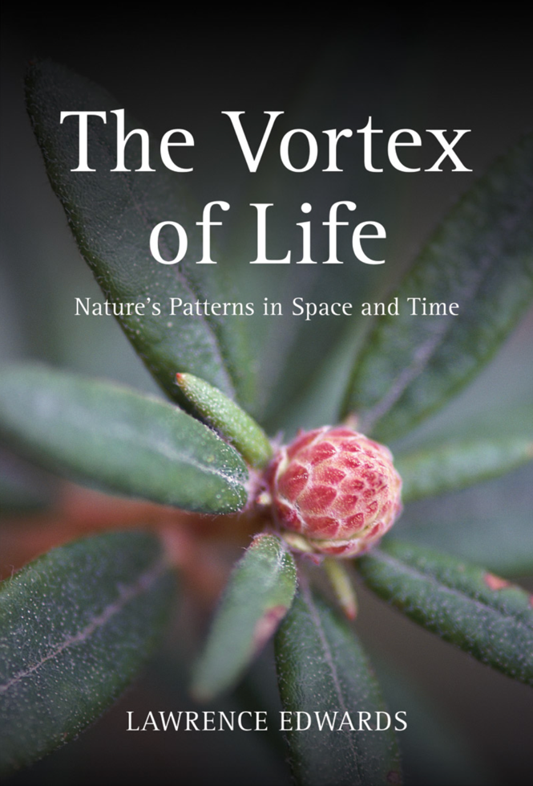
INTRODUCTION: To investigate correlations of lunar position with the shape of beech tree buds, a field study has been conducted based on the work of Lawrence Edwards, as documented in his astounding publication titled The Vortex of Life.

METHODOLOGY: A three-month dataset was collected in the autumn of 2021 (October 1 – December 18) in Seattle, Washington. The live bud was photographed every morning within a 3-hour time window. A box made of acrylic plastic with an opening at each end was used to drop over and surround the bud. The bud was inserted against a black background at the back side of the box, and a smartphone was inserted at the front. Diffused lighting was created using translucent plastic and LEDs on the sides of the plastic box. This improved "picture box" technique was devised for consistency between the daily photographs, in that the bud and camera were always the same distance apart, the lighting was consistent, and the live bud itself would be free of equipment or other unnatural effects, excepting the very short time interval each day when the pictures were taken.
The images were carefully measured using photo analysis software developed specifically for this purpose by Graham Calderwood, the editor of the book referenced above. A specific landmark is chosen which can be identified across months of photos to define the bottom pole of the bud. The software then creates the intermediate vertical diameter locations by equal divisor automatically. Two photo examples from the software are shown below.
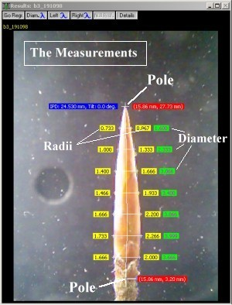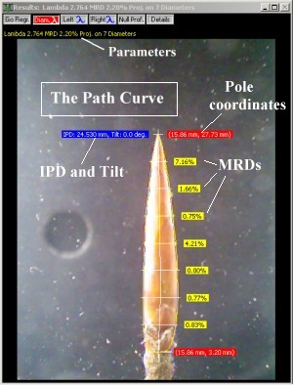
For each day, the seven diameter measurements were synthesized in a formula (described in the book above) such that a single output value is derived which describes the curved line along the edges of the bud. The name given to this output value is "lambda.” A pointier bud will have a "higher lambda" value, and a stubbier bud will have a "lower lambda."
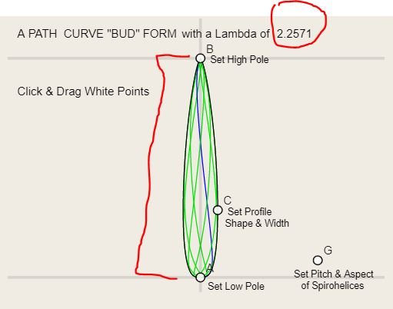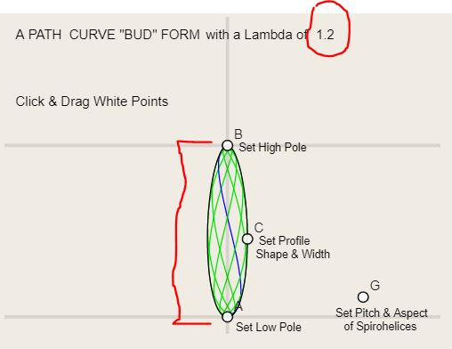
The derivation of the lambda value is not necessarily required to conduct measurements of the bud. In fact, I have tried several different techniques involving direct measurement. The derived lambda value happens to be one of the most accurate ways of describing the curved edge of the bud and a very precise way of tracking changes in the curved shape of the bud's edge over time, but other descriptors such as raw measurements of one diameter could theoretically be used if the field equipment were precise enough.
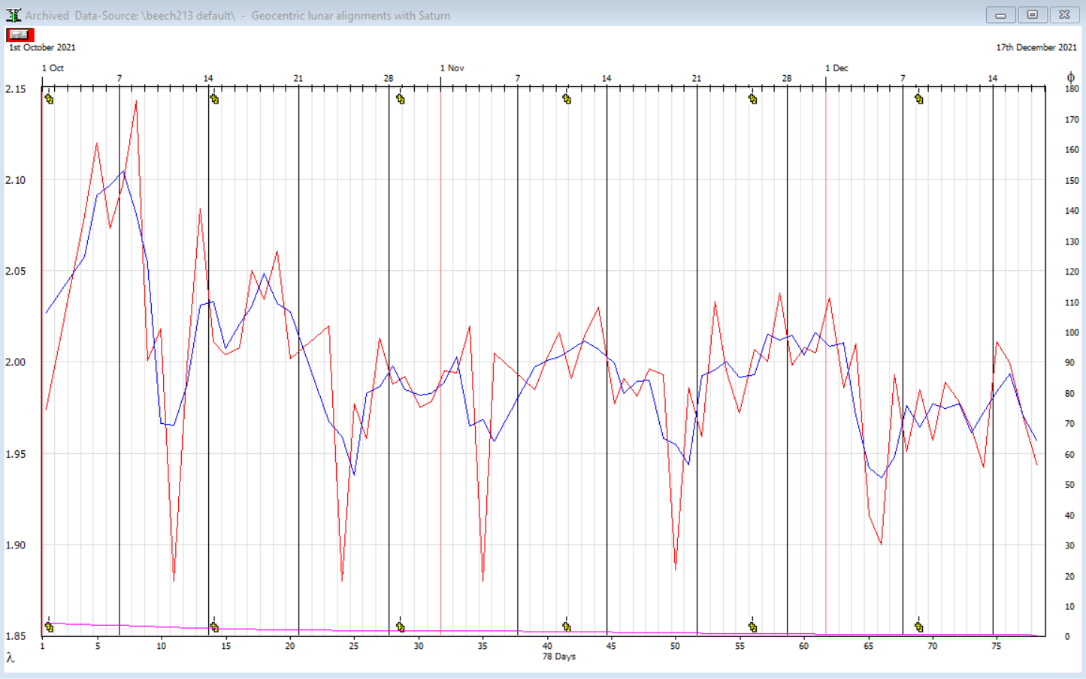
FINDINGS: The bud changed shape on a fortnightly rhythm. In the chart below, five "dips" can be seen over time in the changing lambda value, which is shown on the left axis. Approximately every two weeks a dramatic, short-lived change appeared in the shape of the bud, as shown by the daily lambda value (red tracing; the blue tracing is a three-day running average). A larger dataset is needed to establish a direct correlation with lunar positions over time, but this initial study is very encouraging.

ADDITIONAL RESEARCH: This initial study is part of a larger project to replicate more of the exciting findings outlined in The Vortex of Life. Namely, the specific correlation between Earth-Moon-Saturn alignments and the beech bud shape changes, which is predicted in the larger datasets from Lawrence Edwards and Graham Calderwood. My dataset discussed here is not extensive enough to comment about those planetary alignment nuances, but the groundwork has been set to replicate those findings as well.

This type of direct bridge between earth and planets other than the moon, evidenced by plants on Earth, would be a vast new area of systems ecology!

Calendar of Events

May 11-14: The Evolving Course of Science: Science and the Foundation Stone at one hundred years, Ann Arbor, MI
North American Natural Science Section Conference. Information here.

August 9-12: 6th Annual International MysTech Conference, online & Pine Hill Waldorf School, Wilton, NH
“Deploying Resonance for Good.” Information here.

From our Facebook Page
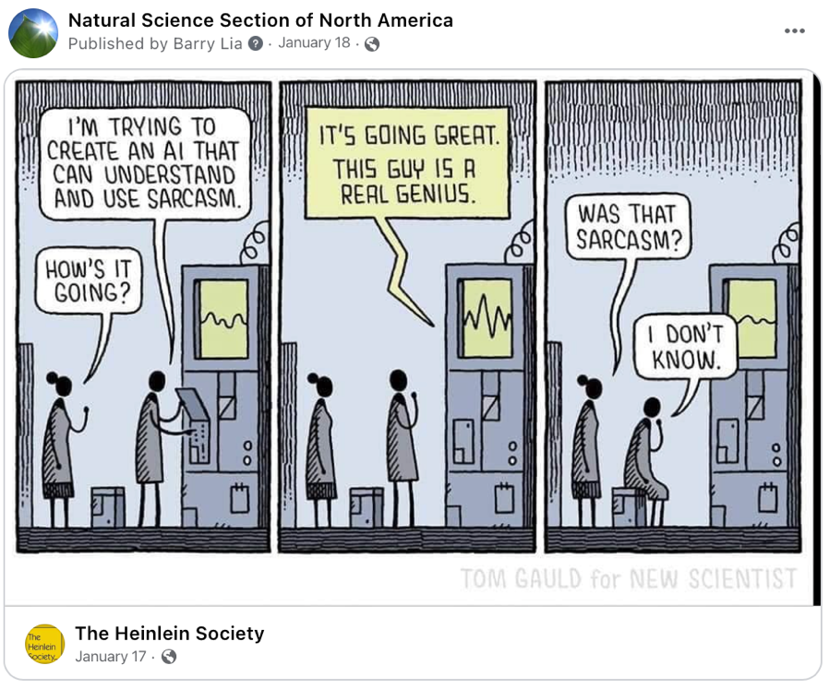

Input:

Write a poem in the style of ChatGPT.

Output:

I cannot do that.
It’s self-referential.
It’s indeed a fact,
I’ve no real potential.

And don’t miss this video!
It’s a hoot.

Please Support Our Work
Please consider making a financial contribution in support of our mission to bring a discerning and unique perspective on developments in science and technology to the Society’s membership and out into today’s culture.
The epistemological foundation of anthroposophy is not only a matter of scientific method. Having a strong foundation in the scientific basis for a monistic science of spirit-matter is important for a healthy attitude towards conventional science today and to overcome its materialistic bias. This is important for all of us working with anthroposophy to further our culture today, be we teachers, farmers, doctors, therapists, artists, entrepreneurs, or anyone seeking to heal the contemporary worldview.
Support for German-to-English translation is especially desired.
Your donation of any amount will help us better serve the Society.
(It is possible to set up recurring monthly donations.)
To donate, click here or find a PayPal button on our website.
Or mail check payable to “Natural Science Section” in care of our Treasurer, Barry Lia at:
Anthroposophical Society in America, 1923 Geddes Ave, Ann Arbor, MI 48104
Thank you kindly for your consideration.

Natural Science Section
www.forschungsinstitut.ch/en/
Mathematics-Astronomy Section
mas.goetheanum.org/en/mas/
School for Spiritual Science
Anthroposophical Society in America
anthroposophy.org
www.naturalsciencesection.org

Correspondence
Issues archive: www.naturalsciencesection.org/correspondence/
Subscriptions: subscriptions@naturalsciencesection.org
Submissions: editor@naturalsciencesection.org
Editor: editor@naturalsciencesection.org
Website issues: info@naturalsciencesection.org
Treasurer: Barry Lia, c/o Anthroposophical Society in America, 1923 Geddes Ave, Ann Arbor, MI 48104
Disclaimer: The opinions expressed are the authors’ own and do not necessarily reflect the views of the editor or members of the Natural Science Section of the Anthroposophical Society in America.

We should have our own report on this conference in the next issue of the Correspondence.
A description of this controversy and intervening experiments may be found on pp. 190-192 here.
The Origins of Natural Science, Lecture IV, 27DEC22, p.58, Anthroposophic Press (1985; ISBN 0-88010-140-7)
Seeing Colour, available here.
http://budworkshop.co.uk/bw_prog.htm

